

CHINESE: SECOND LANGUAGE ORAL

STAGE 2 SAMPLE EXAMINATION

Section 7 of the New WACE Manual: General Information 2006–2009 outlines the policy on WACE examinations.

Further information about the WACE Examinations policy can be accessed from the Curriculum Council website at http://newwace.curriculum.wa.edu.au/pages/about_wace_manual.asp.

The purpose for providing a sample examination is to provide teachers with an example of how the course will be examined. Further finetuning will be made to this sample in 2008 by the examination panel following consultation with teachers, measurement specialists and advice from the Assessment, Review and Moderation (ARM) panel.

0000.doc



Western Australian Certificate of Education, Sample External Examination

Preparation Booklet

CHINESE: SECOND LANGUAGE
Please place your student identification label in this box
ORAL PAPER
STAGE 2

Student Number: In figures

In words

Time allowed for this oral examination
Reading/planning time: 15 minutes
Oral Examination: 15 minutes

Material required/recommended for this examination

To be provided by the supervisor
Preparation Booklet

To be provided by the candidate
Standard items: Pens, pencil, eraser or correction fluid, highlighter, ruler, printed monolingual dictionary and/or bilingual dictionary (not electronic and not a thesaurus).

Important note to candidates
No other items may be taken into the preparation or examination room. It is your responsibility to ensure that you do not have any unauthorised notes or other items of a non-personal nature in the preparation or examination room. If you have any unauthorised material with you, hand it to the supervisor before reading any further.

Structure of this oral examination

Sections | Time  allocation | Number of questions available | Number of questions to be attempted
Preparation | 15 minutes
Monologue | 5 minutes | 5 picture stimulus | 1 | 15
Interview | 10 minutes |  | 1 | 10
 |  |  | Total marks | 25

Instructions to candidates
1. The rules for the conduct of Curriculum Council examinations are detailed in the Student Information Handbook. Sitting this examination implies that you agree to abide by these rules.
2. The total time allocated for the oral examination is 30 minutes (15 minutes preparation and 15 minutes stimulus monologue and interview).
3. During preparation time, you will prepare responses to the stimulus materials and role play situation and make notes as required. You may refer to monolingual and/or bilingual dictionaries during the preparation time.
4. Notes made during the preparation time must be handed to the examiner and may not be used during the interview. Dictionaries must be handed to the examiner and may not be used during the oral examination.
5. Instructions for each section of the oral examination are given in this preparation booklet.

PREPARATION

There are TWO sections to the oral examination: a discussion and a role play.
You will have 15 minutes to prepare for the two sections in a separate room. Make sure you allocate 15 minutes to each section.

SECTION ONE: Stimulus monologue (5 minutes)

You will be given five stimulus pictures. Choose one and make notes using the picture.

Your notes should relate to a personal situation and your view on the content of the picture.

You will present an unrehearsed monologue response to the stimulus.

Examiners may prompt if required. You can make notes in the preparation time and refer to the notes during the examination.

SECTION TWO: General conversation based on 2A/B unit description (10 minutes)
Conversation with prompts

You will be engaged in general conversation based on 2A/B unit description and themes. Wherever possible questions will be open and prompts may be used by examiners.

General introductory questions will be used by the examiner to initiate the conversation followed by questions related to the stimulus picture.

.

SECTION ONE: Stimulus monologue 5 minutes (15 marks)

SAMPLE PRINT TEXTS

Text 1

For copyright reasons the cover of the tourist map of China cannot be reproduced in the online version of this document.
Text 2

For copyright reasons the image of the terra cotta warriors cannot be reproduced in the online version of this document.

[From: China National Tourism Administration]

Text 3

- 00 朝闻天下
- 08:36 天天饮食：2006-277
- 08:49 夕阳红
- 09:25 电视剧：真情年代7/30
- 10:16 电视剧：真情年代8/30
- 11:08 电视剧：真情年代9/30
- 12:00 新闻30分
- 12:39 今日说法：2006-305
- 13:09 电视剧：月牙儿与阳光19/30
- 14:12 电视剧：月牙儿与阳光20/30
- 15:04 走近科学（精编版）：2006-274
- 15:33 健康之路周刊：2006--44
- 16:06 半边天：2006-220
- 16:36 科技博览：2006-220

Text 4

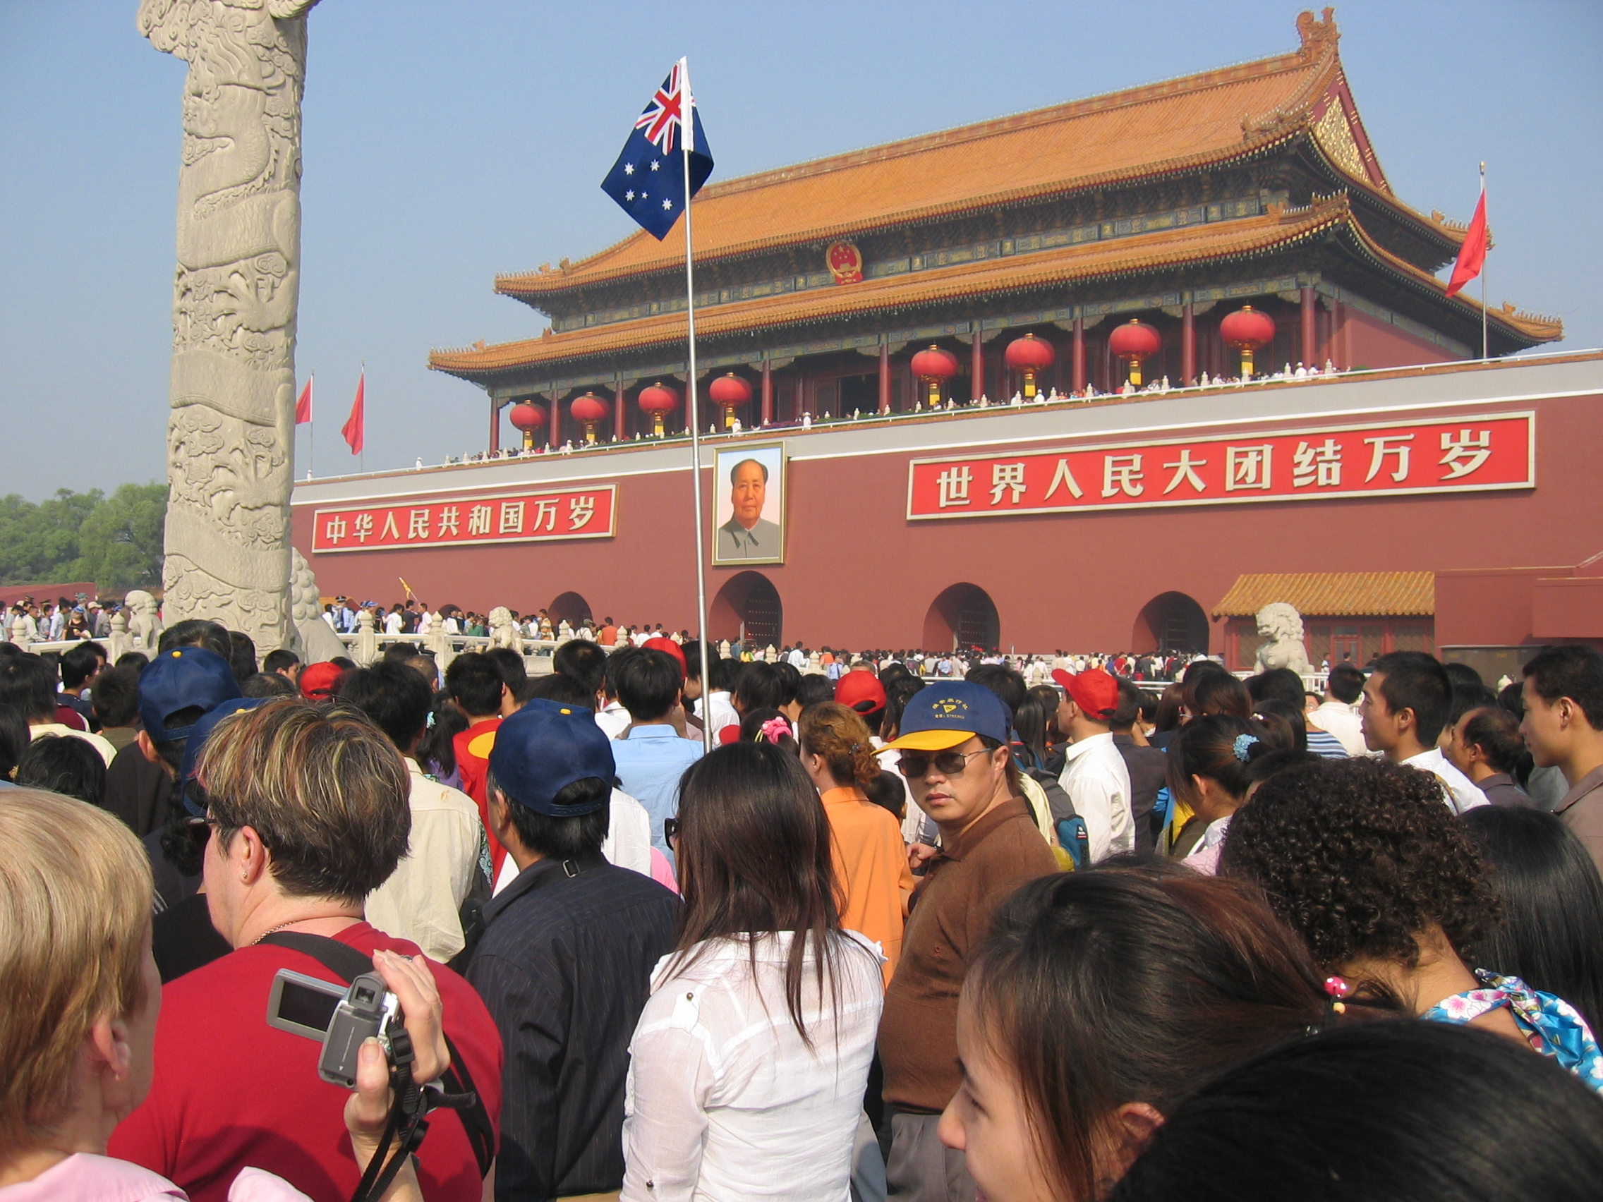
[A. Chong]

Text 5

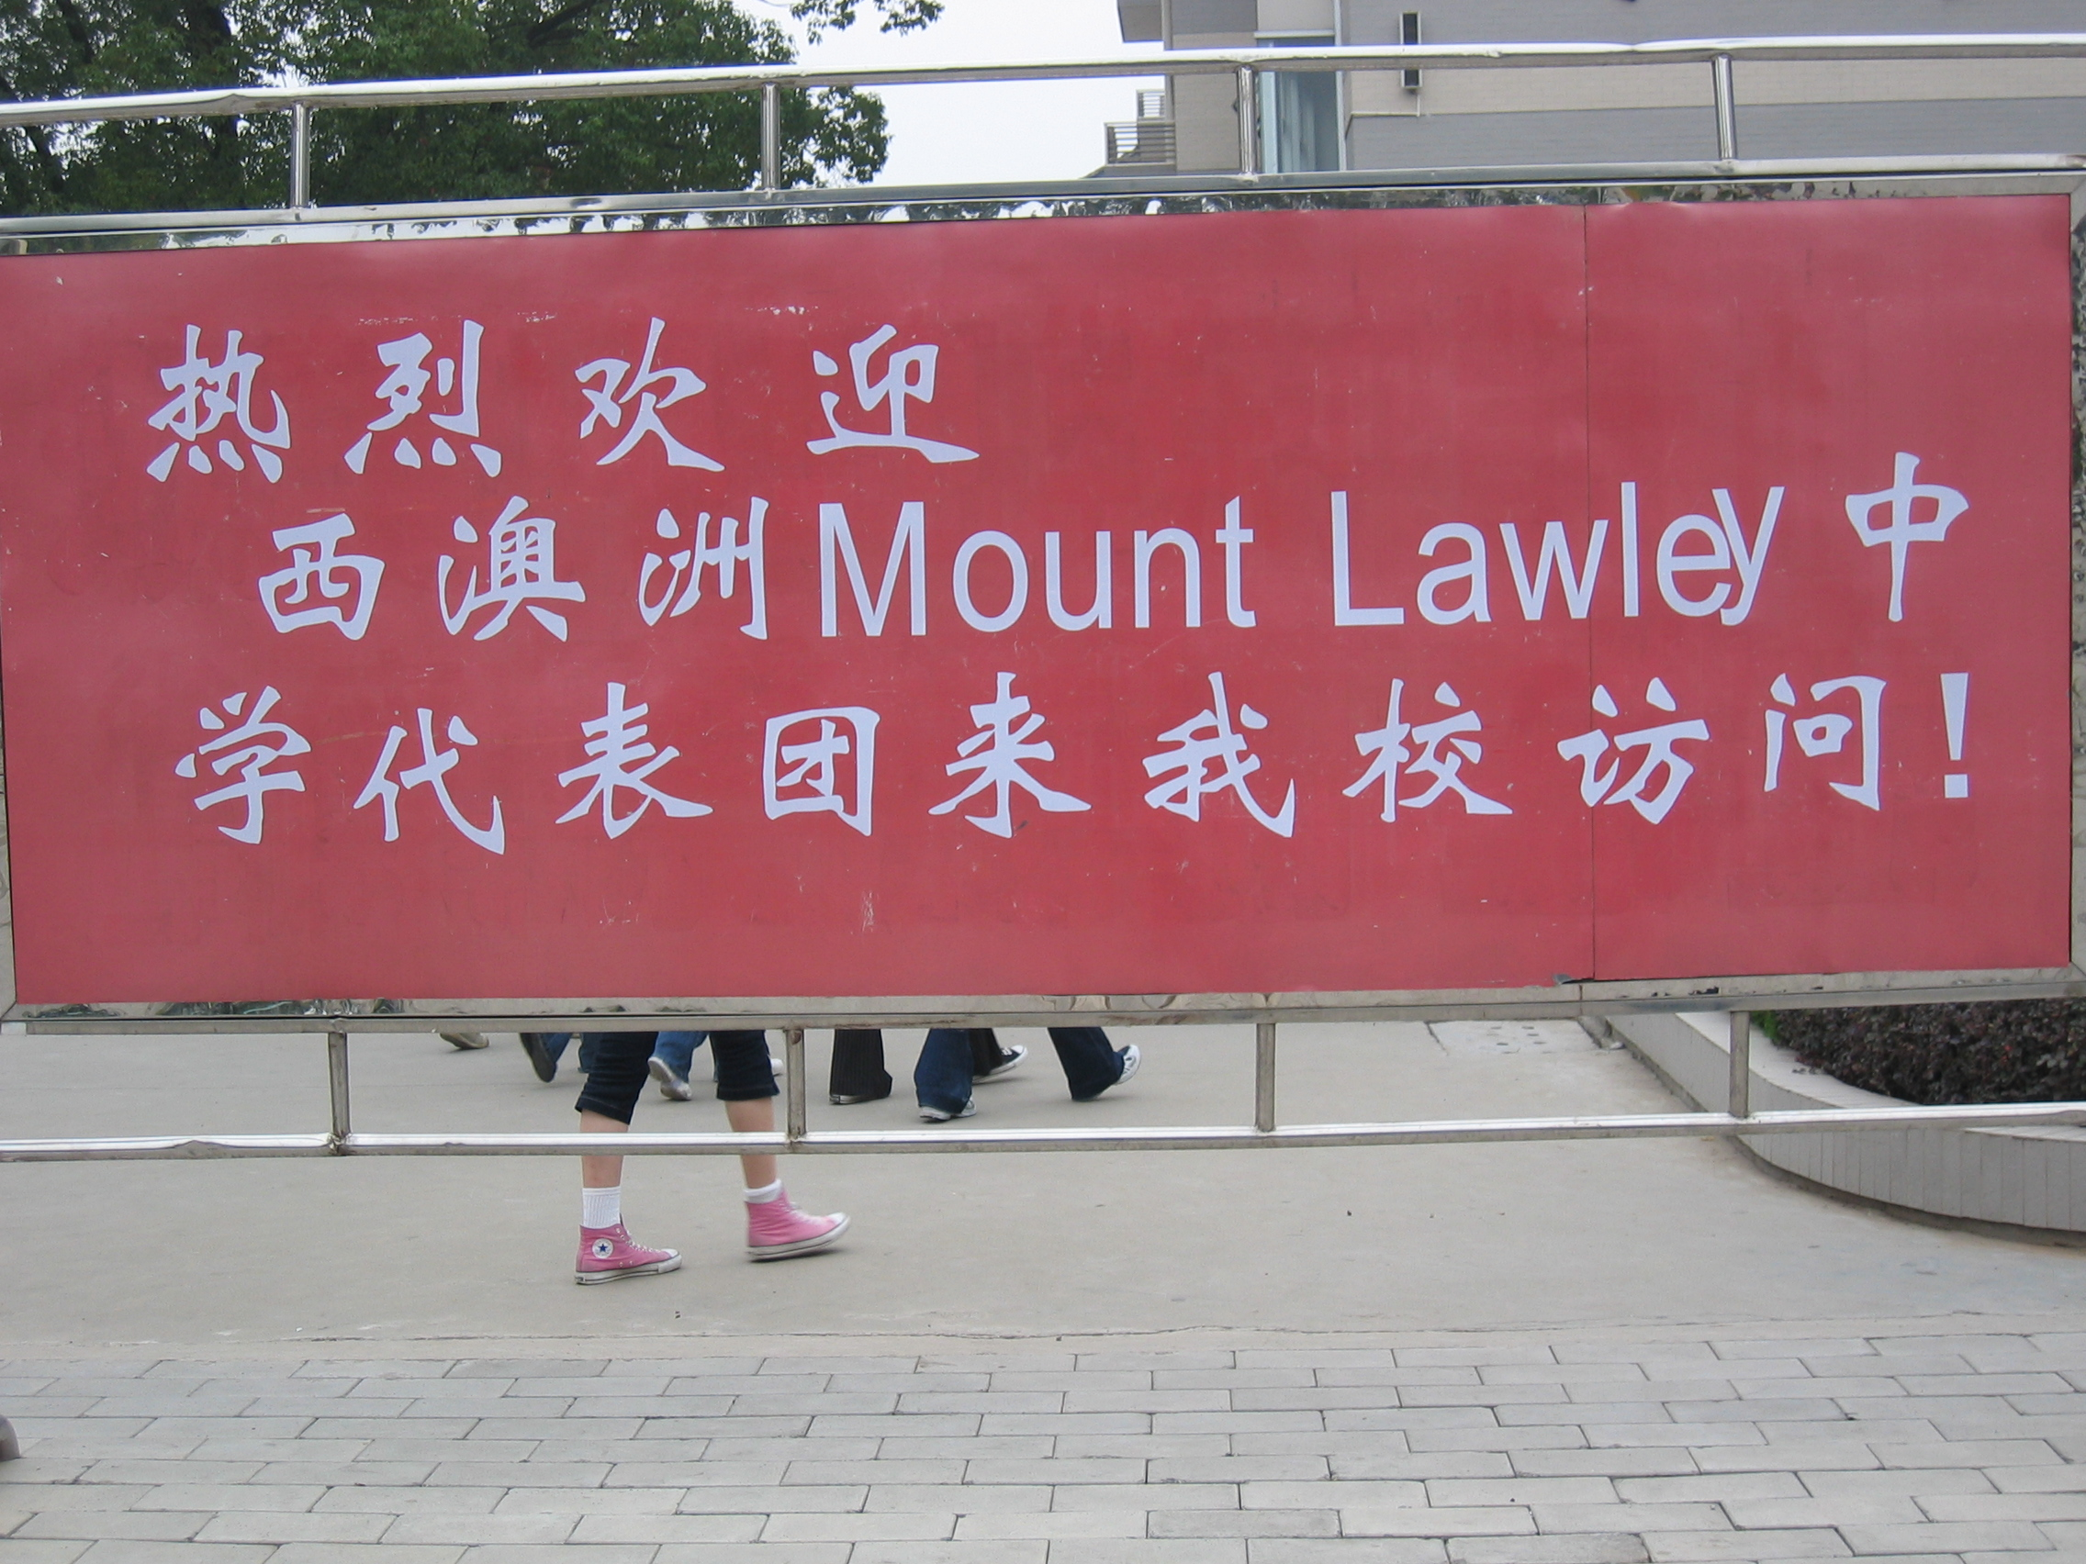
[A. Chong]

NOTES:

General introductory questions will be used by the examiner to initiate the conversation of the stimulus text related to the nationally required themes of The Individual, The Chinese-speaking Communities and The Changing World, which reflect the themes from Stage 2 units (‘the Chinese way’; and ‘travel’) according to the students’ selections.

Warm up interview—2 minutes

Greetings
Weather
Family
Likes and dislikes
Preferences

Sample question

How are you today?
What do you like to do on the weekend?
How many are there in your family?
Who is your best friend?
What do you do on the weekend?
Do you like sport?
What are your hobbies?
Do you like going to the movies?
Do you enjoy travelling?
What is your favourite place that you have been to?
What is your plan after you finish school?

SECTION TWO: Conversation 10 minutes [10 marks]

Ex: Text 2

Student introduces text 1

This is a Chinese restaurant.
It sells dumplings, noodles.

Examiner: Do you often eat out?
Answer: My family likes to go to Chinese Restaurant. We don’t often
Go. We go to a restaurant to celebrate birthdays.

Which is your favourite restaurant?
I don’t have one. My parents like to go to many different ones.

Do you eat Chinese or western food at home?
We usually eat Chinese food, but sometimes my mum cooks western food. I mostly like steak and chips.

Which do you prefer?
Chinese.

What is your mum’s best dish?(nashou haocai)
I like her fried noodles.

Why?
Because she puts in a lot of seafood. I like prawn best.

Possible situations:
You have a Chinese visitor and you are planning the weekend activities.
You are to find out what the visitor would like to do and try to match it to your preferences.

For example:
Student:
The weather is going to be nice this weekend. Where would you like to go?
Examiner:
I hear Western Australian beaches are very beautiful.
Student:
The beach is too hot. We should go there this afternoon. Have you been to King’s Park?
Examiner:
No, where is King’s Park?
Student:
It’s close to the city. We will catch a bus from the city. From King’s Park we can see the whole city.
Examiner:
That will be nice.
Student:
We can then take a train to Fremantle and have fish and chips for lunch. We can also visit the market.
Examiner:
That’s Saturday; what about Sunday?
Student:
We will sleep in tomorrow as we are going to meet a couple of friends and we are going to Northbridge to have dinner at a hotel. Maybe catch a movie if you don’t feel like nightclubbing.
Examiner:
I would like to see a kangaroo or two.
Student:
I know where we can go on Sunday, the wildlife park. You can see a lot of Australian animals there.
Examiner:
My lecturer told me Australian wines are excellent.
Student:
That’s right. You must try our wines.
Examiner:
I am going on a Day Tour to visit some wineries.
Student:
I will go with you.

ACKNOWLEDGEMENTS
Published by the Curriculum Council of Western Australia
27 Walters Drive
OSBORNE PARK WA 6017

Text 1 China National Tourism Administration. (n.d.). China: Tourist map of China. Beijing: Author.

Text 2 China National Tourism Administration. (n.d.). China: Tourist map of China. Beijing: Author.

Texts 4 & 5 Photographs by kind permission Anita Chong.

